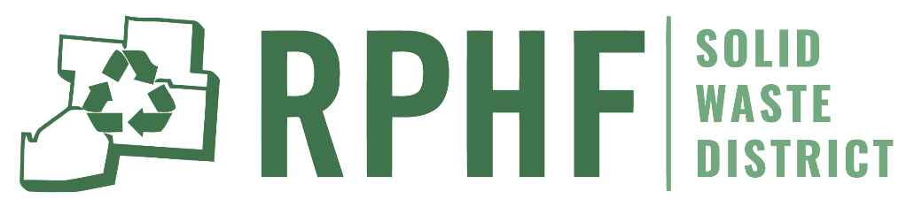

2025 Community Clean-Up Grant Program
Handbook and Application

Deadline to apply: March 1st, 2025.

An electronic version of this publication including application forms is available upon request.

Contact Information:
Ross Pickaway Highland Fayette Solid Waste District
PO Box 1124, Circleville, Ohio 43113
740-420-5452
RPHFSolidWasteDistrict.com

Community Clean-Up Grant Summary
An incentive grant program to encourage litter prevention, recycling, and community beautification. Eligible applicants may be awarded funds to assist with costs associated with community clean up events.

Eligibility
Municipal corporations, board of education, businesses, park districts, health districts and not-for-profit organizations within Ross, Pickaway, Highland, or Fayette County. The “applicant” on the attached application form refers to the agency or organizations applying for grant funds and who will be responsible for securing matching funds.
Eligible Uses of Grant Funds
Costs associated with conducting recycling and litter cleanup and prevention events. This includes but may not be limited to costs for safety supplies and disposal fees such as dumpster/landfill, scrap tire, electronics, and hazardous waste.

Grant Amount
The maximum grant award will be $5,000. However, the RPHF Solid Waste District reserves the right to make grant awards more than this amount should circumstances merit or to offer a partial grant for less than the total amount requested.
Cash Match Requirement
This program will provide up to 90% of the total project costs for a maximum of $5,000.00. Applicants are required to pay at least 10% of the total project costs.
Example: Grant pays $5,000 and applicant pays $500 toward a project totaling $5,500.
However, the RPHF Solid Waste District reserves the right to provide grant percentages of more or less than 90% should circumstances merit. Costs for supplementing existing employees’ salaries are ineligible.

How to Apply
To apply for the 2025 Community Clean-Up Grant Complete Forms #1 through #4 on the following pages and submit forms to one of the following choices:
- Email to lshreve@pickawaycountyohio.gov
- Mail to RPHF Solid Waste District Main Office, PO Box 1124, Circleville, Ohio 43113
- Drop your completed application off at the RPHF Solid Waste District Main Office 141 W. Main Street, Suite 400, Circleville, Ohio 43113
Application Deadline: March 1, 2025.

Grant Program Timeline
Grant funding will be determined by the RPHF Solid Waste District within 30 days of application due date. A grant agreement will be mailed to the grantee shortly thereafter detailing the grant award and the process for receiving payment. The Grant Applicant is expected to pay all expenses necessary to complete the grant prior to submitting bills to the RPHF Solid Waste District for the agreed upon amount of reimbursement. Reimbursement will not exceed 90% of actual expenditures. The deadline for the completion of work by awardees, and the submission of a Project Completion Report (Form #5) with attached copies of paid bills to the RPHF Solid Waste District is November 1, 2025.
NOTE: If all grant funds are not awarded by June 1, 2025, additional applications may be accepted up to July 1, 2025, with a determination on funding being made by August 1, 2025. The project completion date remains November 1, 2025.

RPHF Solid Waste District
2025 Community Clean-Up Grant Program
Application Deadline: March 1, 2025

Form # 1 – General Project Information
Applicant: | Applicant Phone:
Applicant Address: | Applicant Project Coordinator:
Email Address of Applicant Coordinator: | Direct Phone # of Coordinator:
Project Title: | Brief Description of Project & Location
Total Project Cost: | Amount Requested from the RPHF Solid Waste District (max. of 90% of Total Project Cost):
Sources of Additional Funds to be Utilized on This Project: | Projected Project Completion Date:

RPHF Solid Waste District
2025 Community Clean-Up Grant Program

Form # 2 – Detailed Project Description
Project Title:

Location(s) of Proposed Project:

Describe in detail the proposed project, including the reason said project is needed, those
responsible for completing the project, the local support for the project (letters of support may
be added to end of the application, but are not required), and the proposed timeline for
completing the project. Activities should not start until a signed agreement is executed between the applicant and the RPHF Solid Waste District and should be completed by
November 1, 2025, including the submission of a completion report.
Attach additional pages if necessary.

RPHF Solid Waste District
2025 Community Clean-Up Program

Form # 3 – Detailed Project Budget
Expense Description | Estimated Cost | Applicant Share | Grant Amount
Total Project Costs |  | Minimum of 10% | Maximum of 90%
Costs for supplementing existing employees’ salaries are ineligible.
Additional Comments:

RPHF Solid Waste District
2025 Community Clean-Up Program

Form # 4 – Authorizing Resolution
Below is an example of a form that is required to be submitted with each application. This form,
or one similar to it, identifies that the officials responsible for the actions of the applicant are aware and supportive of the proposed project.
RESOLUTION OF AUTHORIZATION
WHEREAS, the RPHF Solid Waste District administer a financial assistance program for solid waste, recycling and litter management purposes through the 2025 Community Clean-Up Program, and
WHEREAS, the ___________________________________ desires financial assistance under
(Name of applicant)
the Community Clean-Up Program.
NOW, THEREFORE, be it resolved by the _______________________________________
(Applicant Name)

1) That the ____________________________________ approves filing an application
(Name of applicant)
for financial assistance.
2) That ____________________________________ is hereby authorized and directed
(Name of local coordinator)
to execute and file an application with the RPHF Solid Waste District and to provide all
information and documentation required to become eligible for possible funding assistance.
3) That the ____________________________________ agrees to complete
(Name of applicant)
the project as outlined in the grant proposal should the grant request be awarded.

Signed: _____________________________________________________________
(Authorized Agency Official)

Title: _______________________________________________________________

Date: _______________________________________________________________

RPHF Solid Waste District
2025 Community Clean-Up Program

Form # 5 – Project Completion Report (Due by November 1, 2025 with copies of receipts)
Expense Description | Total Cost | Applicant Share | Grant Amount
Total Project Costs |  | Minimum of 10% | Maximum of 90%

Additional Comments:

